**10 Tips for Air Conditioning**

Beat the heat this summer by having the cleanest, coolest, and most-efficient air conditioner on the block.

### Choosing an Air Conditioner

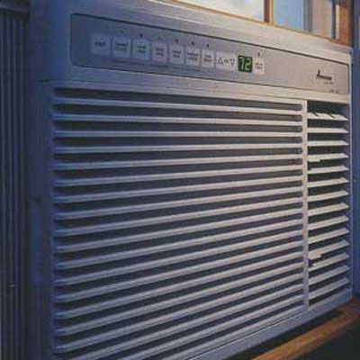

Room air conditioners can quickly cool a broiling bedroom, a sticky family room, and other hot spots in your house for as little as $250. Individual units put the cooling where you need it if the climate in your area does not warrant whole-house air-conditioning or if you don't want to spend $3,000 to $6,000 to have a new central-air system installed.

### Add Central Air

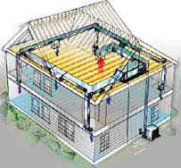Illustration by Alan Daniels

Whether summers are really getting hotter or we've lost our tolerance for heat as we grow older, lots of us are tempted to yank out noisy, dripping window air conditioners and replace them with quiet, efficient whole-house central-air-conditioning systems. But we don't take the idea any further. Those of you with forced-air furnace ducts in place worry that modifying the heating system will be costly and result in inefficiency. And if you don't have ducts, you can't imagine how they're going to be added without destroying the house and costing a bundle. But installing central air is easier and less costly than you might think.

### Keep Dust Away

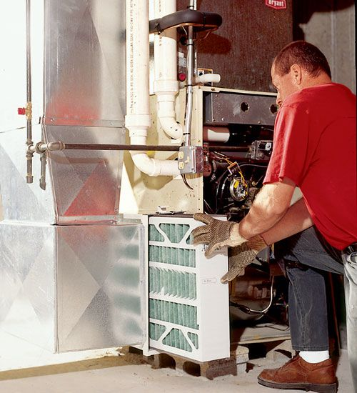

Richard Trethewey gives advice on maintaining a forced-air system to control dust, a unfriendly bug to an otherwise comfortably cool space.

### Install a Portable Air Conditioner

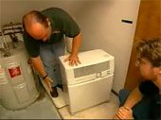

[In this video](https://www.thisoldhouse.com/node/28981), This Old House plumbing and heating contractor Richard Trethewey explains how to get air conditioning where window units aren't practical.

### How to Install a Mini-Split Air Conditioner



[In this video](https://www.thisoldhouse.com/node/28801), This Old House plumbing and heating expert Richard Trethewey explains how to install a mini-split air conditioner.

### Maintaining Your Air Conditioner

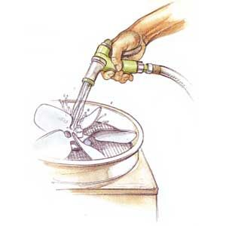Illustration by Narda Lebo

Your central-air unit will run trouble-free for years—if you maintain it.

### Keep the Air Clean

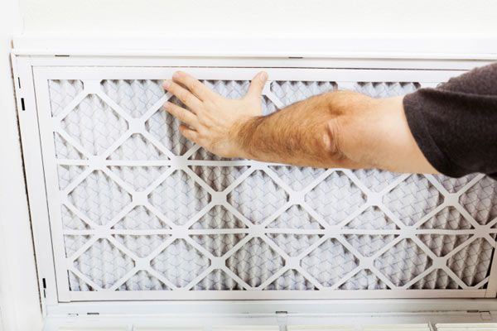Photo by slobo/Getty

That dust collecting on end tables and bookshelves is only a fraction of what's actually swimming around in the air: an invisible mix of dust mites, pollen, dander, mold, and smoke that can be annoying to breathe and hazardous to your health. [Learn how to keep that air clean here.](https://www.thisoldhouse.com/node/3803)

### Choosing Ductless Air Conditioning

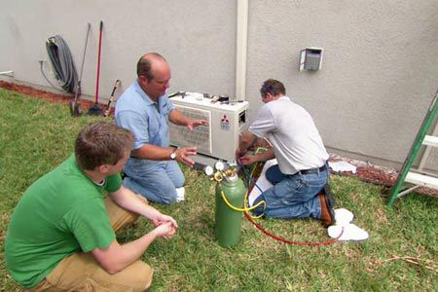

A ductless air conditioner, also called a mini-split system, has two major components: a unit mounted on an inside wall that delivers cool air to the room and a unit mounted on the outside of the house. [Richard Trethewey tells you if it’s the right pick for you here](https://www.thisoldhouse.com/node/7440).

### Transporting an Air Conditioning Unit

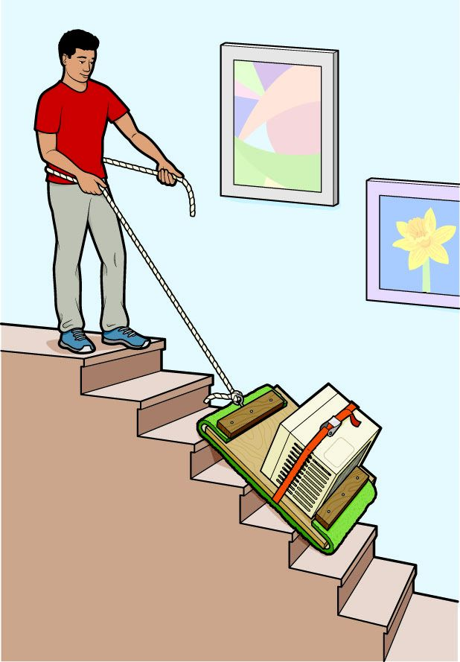Illustration by Brown Bird Design

Carrying it from or to the basement isn’t just challenging, it’s dangerous, partly because it can block your view of the steps.

From：https://www.thisoldhouse.com/heating-cooling/21018961/top-10-air-conditioning-tips